Test Data Set Availability with Test Results

This is the home page of our application. We will input the desired skills for the job in the input field and upload a zip folder, which should contain all the resumes to be scored and ranked.

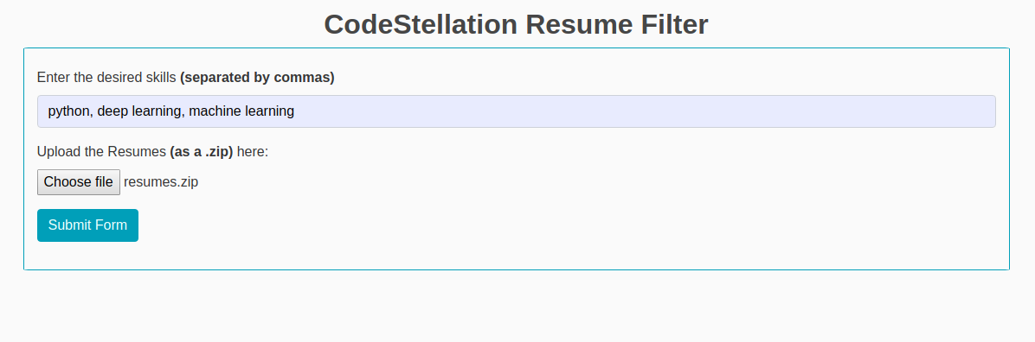
Below is the output. Please note, that the ranking feature will be updated in the next assessment (working prototype).

Our input test data is a .zip folder of resumes.
Our output test results is the score of the resumes, that have been uploaded.

